NAME: PENDEM HARSHITHA
ROLLNO: 2403A510C9
BATCHNO: 05
TASK1:
A travel company wants to show real-time weather updates for its
customers. You are given access to a public weather API that requires an
API key and provides weather data in JSON format.
• Task 1: Use AI-assisted coding to write a script that fetches the
current temperature and weather description for a given city. The
script should handle errors if the API key is invalid or missing.
• Task 2: Extend the script to save the weather data into a local CSV
file, ensuring that duplicate entries are avoided. Implement error
handling for file I/O exceptions
PROMPT:

CODE:
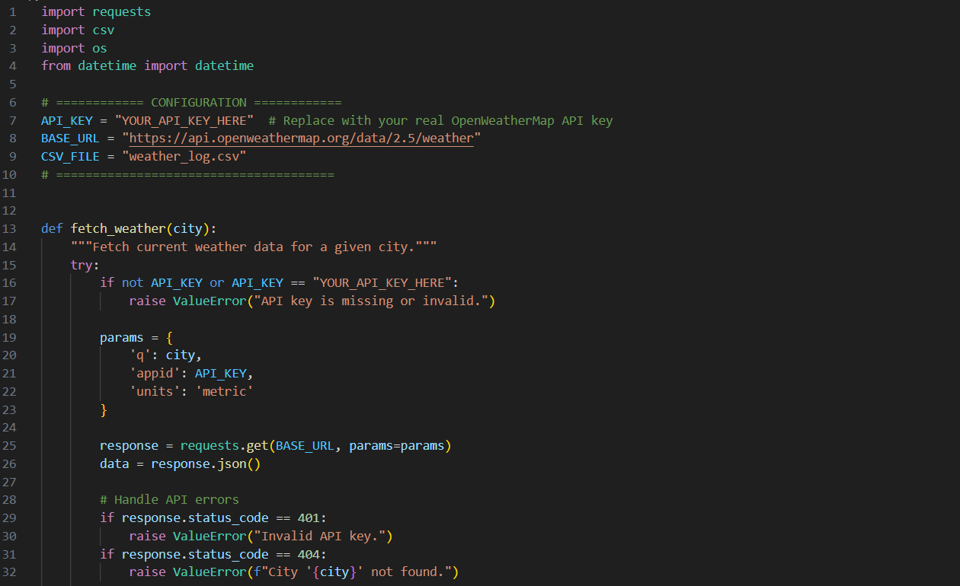
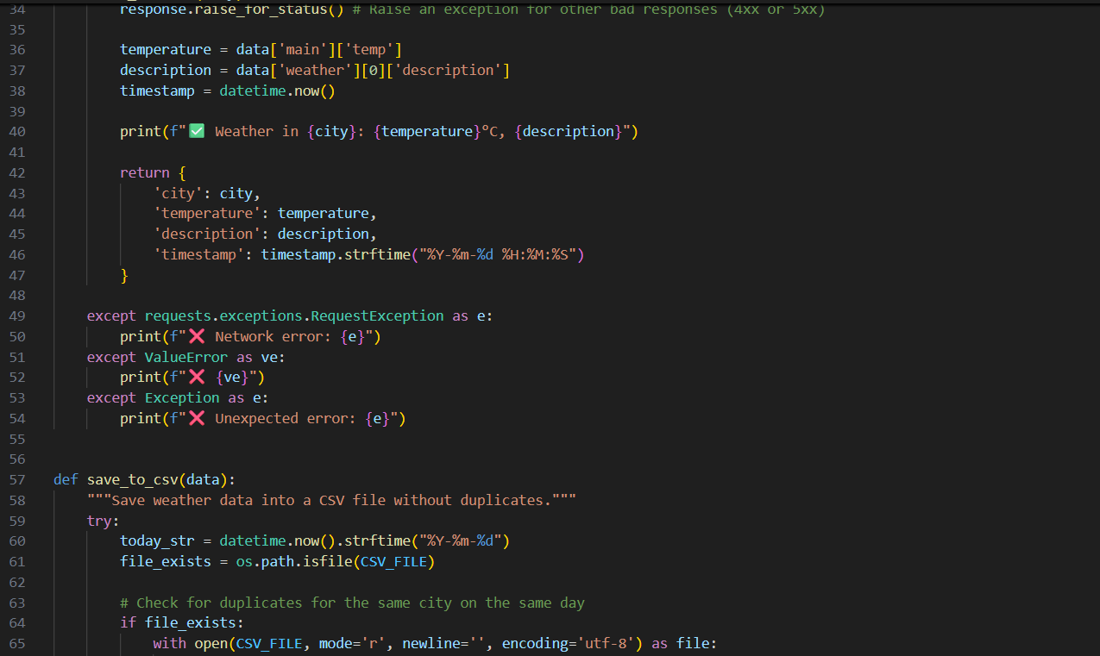
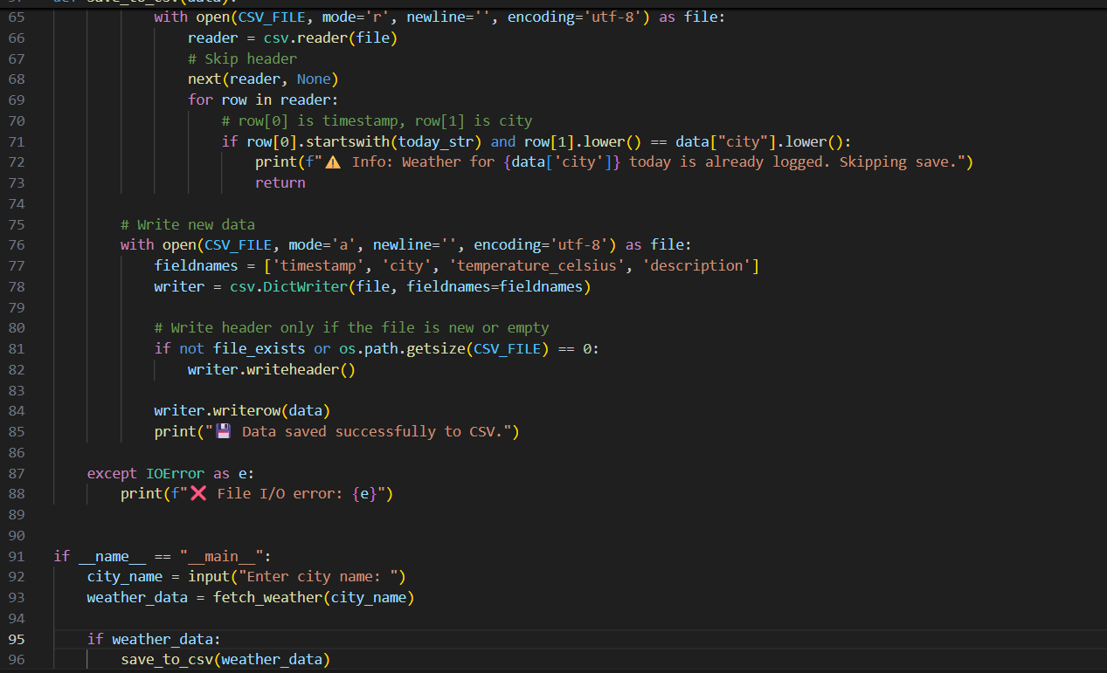
OUTPUT:
OBSERVATION:
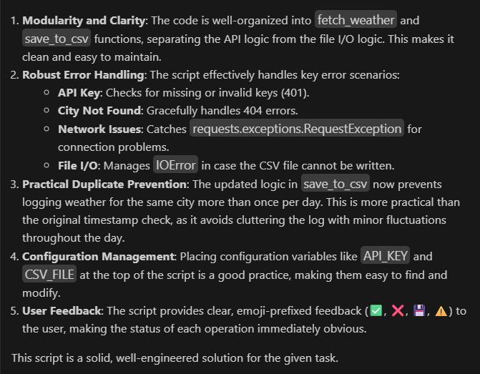
TASK2:
A financial startup needs a tool to convert amounts between currencies
using an exchange rate API. However, the API occasionally fails due to
server downtime.
• Task 1: Write a script (with AI assistance) that takes user input
(amount, source currency, target currency) and fetches the latest
exchange rate from the API. Include errors in handling invalid
currency codes.
• Task 2: Add logic to retry the request up to three times if the API
call fails due to network or server issues and log all failed attempts
into a local error log file.
PROMPT:

CODE:
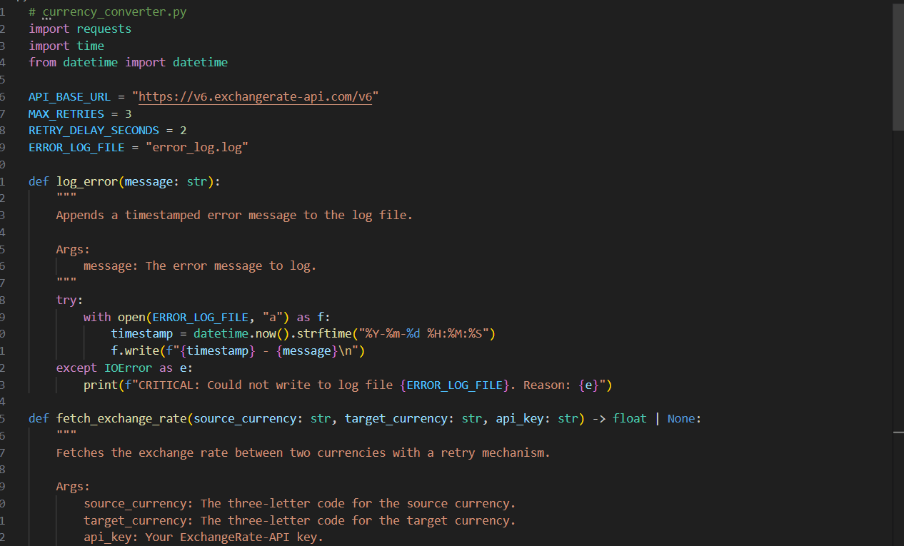
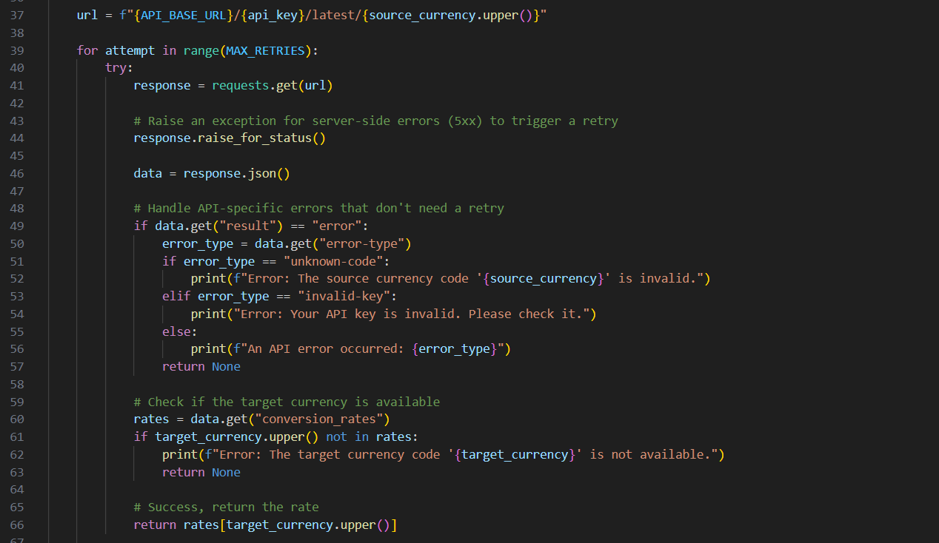
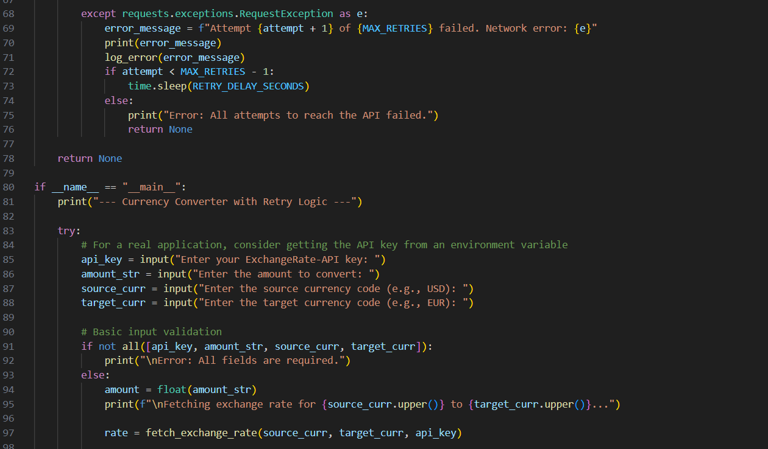
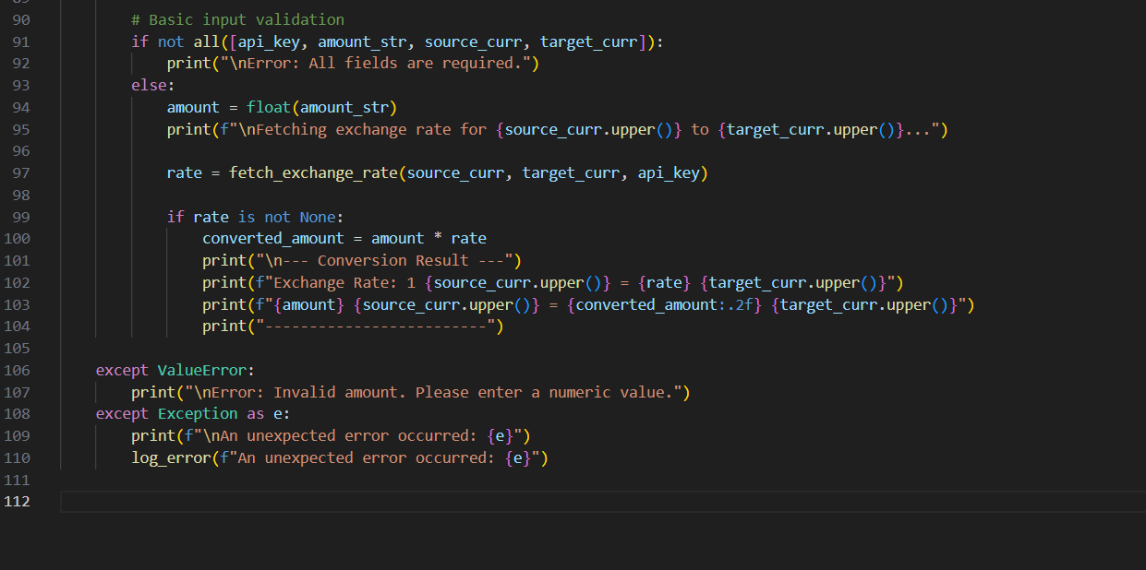

OUTPUT:
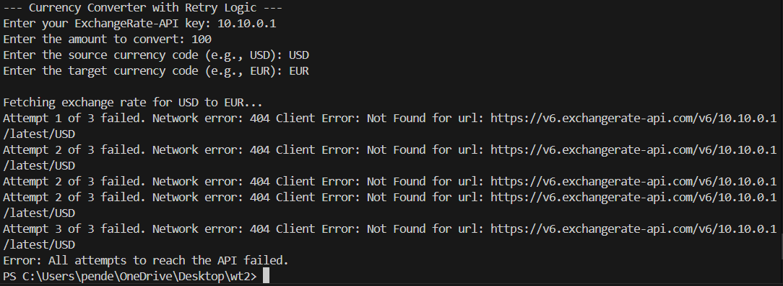
OBSERVATION:
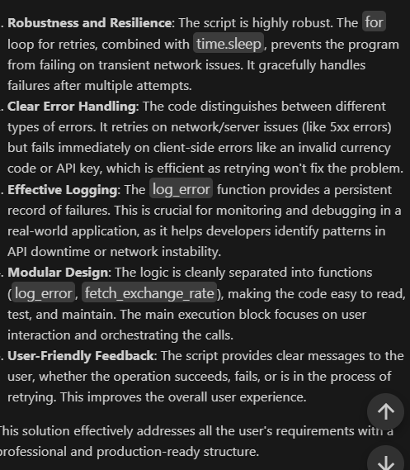
TASK3:
A news aggregator wants to display the latest technology news headlines
using a news API. Sometimes, the API responds slowly or returns
incomplete data.
• Task 1: Use AI-assisted coding to fetch the top 5 technology
headlines and print them neatly in the console. Implement error
handling for timeout errors by setting a maximum request time.
• Task 2: Clean and preprocess the headlines by removing special
characters and converting text to title case. Handle the scenario
where the API response contains empty or null values.

PROMPT:

CODE:
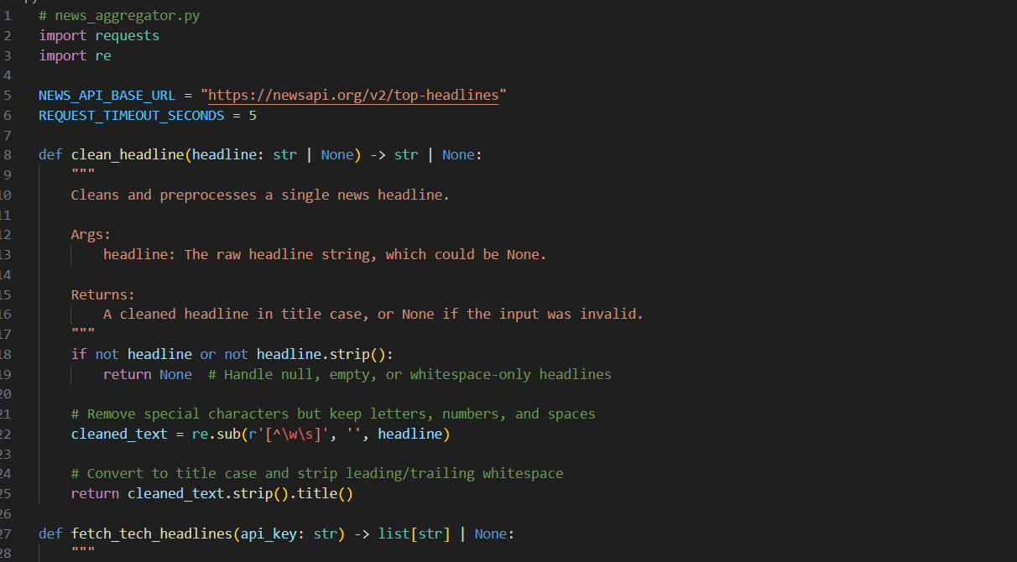
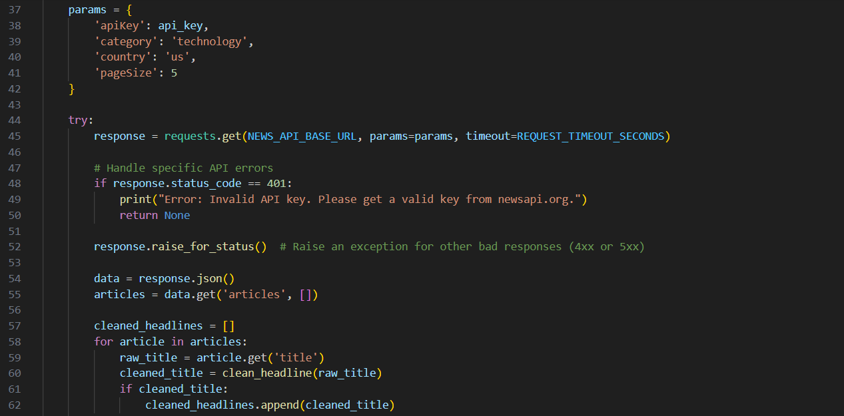
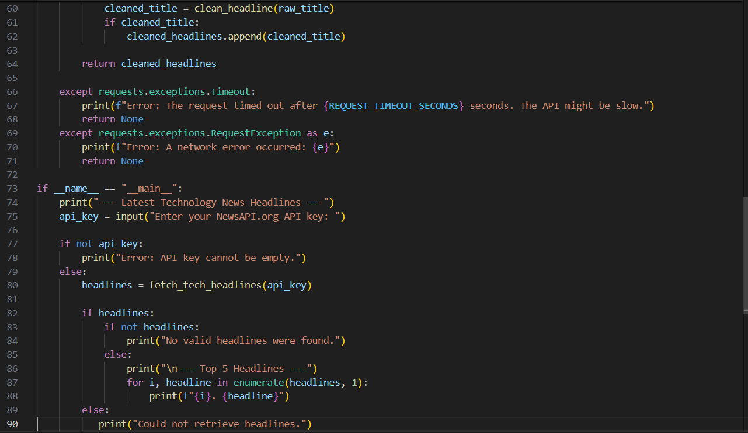
OUTPUT:
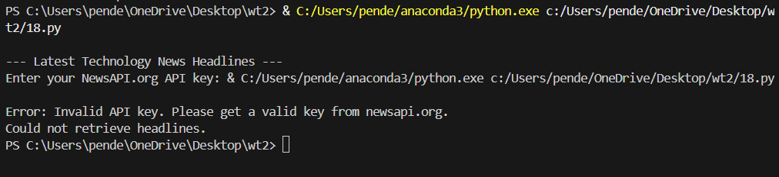

OBSERVATION:
